Ideation Phase
Define the Problem Statements

Date | 8/10/2026
Team ID | 9100Byte
Project Name | Implement Client Script & UI Policy (Incident)
Maximum Marks | 2 Marks

Customer Problem Statement Template:
Create a problem statement to understand your customer's point of view. The Customer Problem Statement template helps you focus on what matters to create experiences people will love.
A well-articulated customer problem statement allows you and your team to find the ideal solution for the challenges your customers face. Throughout the process, you’ll also be able to empathize with your customers, which helps you better understand how they perceive your product or service.
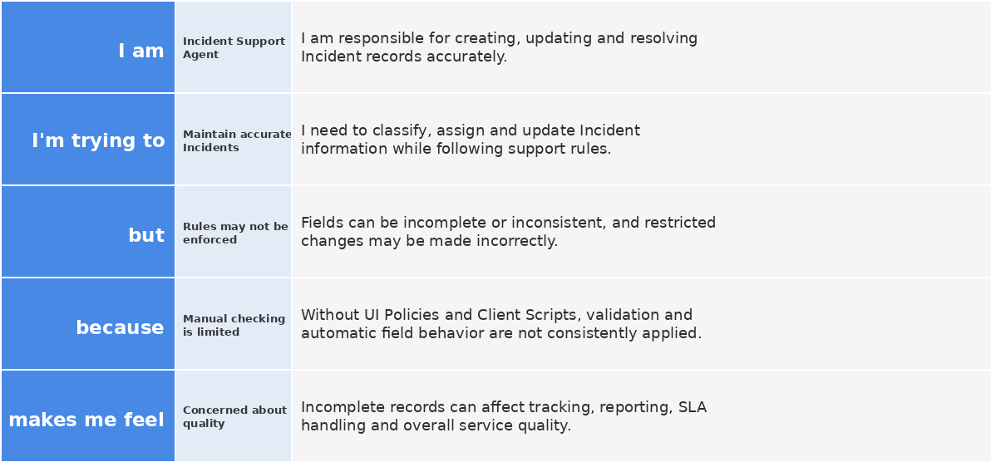
Reference: https://miro.com/templates/customer-problem-statement/
Example:
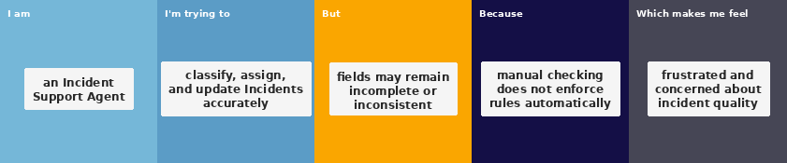
Problem Statement (PS) | I am (Customer) | I’m trying to | But | Because | Which makes me feel
PS-1 | I am a Service Desk / Incident Support Agent | trying to classify, assign, update, and resolve Incident records accurately | important fields can be incomplete or users may enter inconsistent values | manual checking alone does not enforce field behavior or validation at the right time | it is difficult to maintain consistent Incident records and efficient incident handling
PS-2 | I am an Incident Record User | trying to update Incident information quickly while following support rules | high-impact incidents may not automatically enforce the required assignment and urgency behavior | the Incident form needs conditional controls, automatic updates, and save-time validation | I may save incomplete records or make changes that should be restricted

Project Context: The project applies ServiceNow UI Policies and Client Scripts on the Incident form to control mandatory fields, read-only behavior, automatic Urgency updates, save-time validation, and list-edit restrictions.

